Project Design Phase-II
Data Flow Diagram & User Stories
Date | 30 September 2026
Team ID | MKU201Team76ab4df35a238dc999eb5e6de
Project Name | Streamlining IT Procurement: Automating Standard Laptop Orders with Flow Designer
Maximum Marks | 4 Marks
Data Flow Diagrams:
A Data Flow Diagram (DFD) is a traditional visual representation of the information flows within a system. A neat and clear DFD can depict the right amount of the system requirement graphically. It shows how data enters and leaves the system, what changes the information, and where data is stored.
Example: (Simplified) | DFD Level 0: Standard Laptop Order Automation  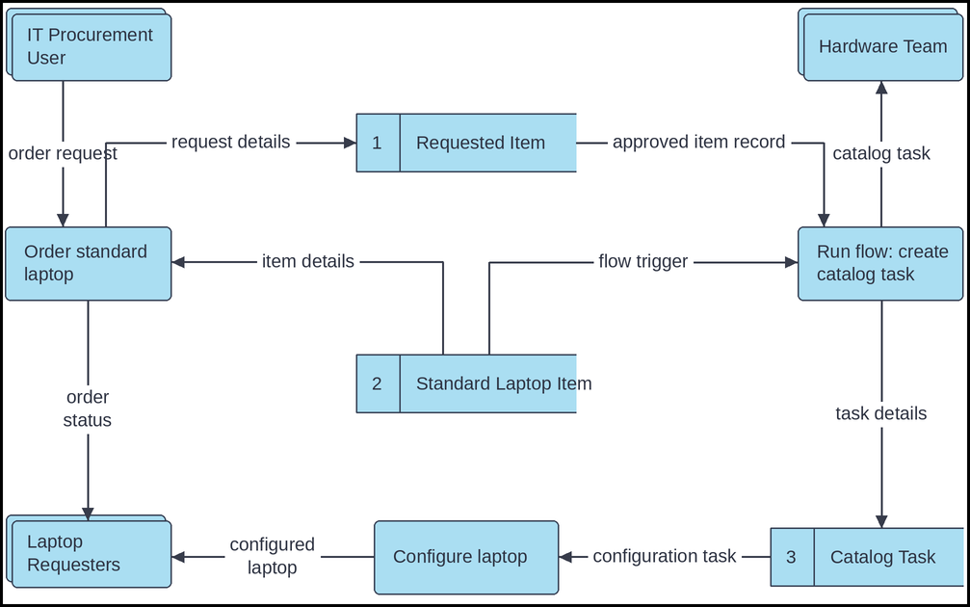
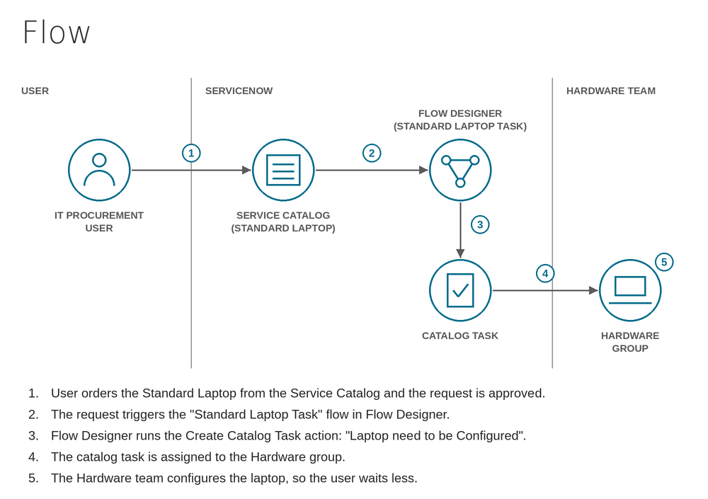
User Stories
Use the below template to list all the user stories for the product.
User Type | Functional Requirement (Epic) | User Story Number | User Story / Task | Acceptance criteria | Priority | Release
IT Procurement User | Standard Laptop Ordering | USN-1 | As a member of the IT procurement team, I can order a Standard Laptop from the Service Catalog by clicking Order Now. | I can see the Order Status and the generated Request Number | High | Sprint-1
 | Request Tracking | USN-2 | As a member of the IT procurement team, I can open the requested item and view its Catalog Tasks so that I can track the configuration. | I can see the catalog task with its short description and assignment group | Medium | Sprint-2
Approver | Request Approval | USN-3 | As an approver, I can approve the laptop request from the Approvers section of the request record. | The request is approved and the requested item is opened | High | Sprint-1
Administrator | Flow Creation | USN-4 | As an administrator, I can create the "Standard Laptop Task" flow in Flow Designer with Service Catalog as the trigger (Global application, Run As System User). | The flow is saved and activated successfully | High | Sprint-1
 | Task Automation | USN-5 | As an administrator, I can add the Create Catalog Task action, mapping the Requested Item record and setting the short description to "Laptop need to be Configured". | A catalog task is created automatically for each approved laptop request | High | Sprint-1
 | Task Assignment | USN-6 | As an administrator, I can assign the created task to the Hardware group with the approval value set to Approved. | The task is assigned to the Hardware group | High | Sprint-1
 | Flow Assignment | USN-7 | As an administrator, I can assign the flow to the Standard Laptop catalog item under Process Engine after removing the existing automation. | The catalog item runs the Standard Laptop Task flow on every order | High | Sprint-2
Hardware Team Member | Laptop Configuration | USN-8 | As a Hardware team member, I receive the "Laptop need to be Configured" task automatically so that I can configure the laptop when it arrives. | The task appears for the Hardware group without manual creation | High | Sprint-2

